GREAT FALLS TRANSPORTATION ALTERNATIVES (TA) PROGRAM
2024 Instructions to Applicants
The Great Falls Metropolitan Planning Organization (MPO) is accepting applications from eligible agencies for projects to be funded with Federal Transportation Alternatives funding. Applicants are asked to limit applications to 10 pages (fewer preferred), providing the following information.
COVER LETTER
Provide a cover letter, signed by all applicants.
PROJECT APPLICANT
Identify project applicant (agency or organization), including primary contact person and contact information. If the project applicant does not own the property upon which the project is or will be located, the property owner MUST be a co-applicant.
Eligible project applicants include:
- local governments (i.e., Cascade County or City of Great Falls);
- tribal governments (i.e., Little Shell Tribe);
- transit agencies (Great Falls Transit District);
- natural resource or public land agencies (i.e., Montana Dept. of Fish, Wildlife and Parks);
- school districts, local education agencies, or schools.
- any other local or regional governmental entity with responsibility for oversight of transportation or recreational trails that the State determines to be eligible (i.e., Great Falls Airport Authority)
PROJECT LOCATION
Accurately locate the project, by description as well as upon a map. Project MUST be entirely within the boundary of the Great Falls Urban Area (see Urban Boundary on the attached Map).
PROJECT DESCRIPTION
- Provide the project name (select simple, descriptive name for the project)
- Describe the project. Be accurate but brief, no more than two pages, and include project type according to eligible project category (found below). More than one eligible category will not be given more weight in the review process.
- on- and off-road pedestrian and bicycle facilities;
- infrastructure projects for improving non-driver access to public transportation and enhanced mobility;
- community improvement activities;
- environmental mitigation;
- recreational trail program projects;
- safe routes to school projects;
- projects for the planning, design or construction of boulevards and other roadways largely in the right-of-way of former Interstate System routes or other divided highways; or,
- activities in furtherance of a vulnerable road user safety assessment.

- Be sure to note any property concerns, such as utility relocations, right-of-way or easement issues, etc.
- Provide detailed information as to who will maintain the project. If it is not the project owner, provide proof of agreement concerning maintenance responsibility.
PROJECT COST
Provide a detailed, accurate project estimate. The project estimate must at a minimum include the following:
- Detailed breakdown of project elements, including project length if applicable.
- Break project costs into:
  - Construction
  - Preliminary Engineering (Design and related costs prior to construction)
  - Utilities (Any private utility re-location costs)
  - Construction Engineering (inspection during construction)
  - Right-of-Way Acquisition (although right-of-way acquisition is an eligible cost, such acquisition is strongly discouraged because of the delay and complexity involved). Projects requiring ROW acquisition will likely not rank as high as projects that do not.
- Apply an inflation rate – projected out 3 years – according to the following table:
2024 | 2.0284%
2025 | 2.0284%
2026 | 2.0284%

- Apply a contingency to the construction project cost. A minimum 20% is recommended.
- Apply a 10.71% Indirect Cost Rate (IDC) to the entire project cost (this fee is charged by MDT to all monies it receives).
- Project cost must also identify the amount and source of the non-federal match. The non-federal contribution to the project must be at least 13.42% of the project cost – but may be more, if the applicant chooses to contribute more to the project than the required minimum 13.42%. There may be some instances where the Montana Department of Transportation will provide the match – contact the TA Project manager for verification, if the project is on a State route.
For assistance in developing a complete, accurate project estimate, a professional engineer should be consulted.
COMPLIANCE WITH LONG RANGE TRANSPORTATION PLAN
Describe the project’s inclusion in the 2018 Long Range Transportation Plan, found here:
https://www.mdt.mt.gov/publications/docs/brochures/great-falls-transportation-plan.pdf
Trail pavement preservation, sidewalk repair and ADA upgrades are assumed to be in compliance with the Plan, and need not be explicitly listed as a project in the Plan.
PUBLIC OUTREACH
List all public outreach efforts related to the project. Note any approvals by governing bodies, if applicable.
SUBMITTAL INFORMATION
Applications must be received by the TA Program Manager by April 19, 2024.
Applications may be submitted in hard-copy or USB flash-drive to:
Andrew Finch, Senior Planner
Planning & Community Development, Rm. 112
City of Great Falls
P. O. Box 5021
Great Falls, MT 59403
Applications may also be submitted electronically via e-mail (in .pdf format) to afinch@greatfallsmt.net. Electronic e-mail submittals must be less than 10 MB, or provided via file transfer or other similar service.
ADVICE FOR APPLICANTS
Before submitting an application, potential applicants are strongly encouraged to contact the TA Program manager, Andrew Finch, to discuss eligibility and project application requirements.
- Ensure there is public support for your project and be prepared to document public engagement. Check to see if your project is included in the current Long Range Transportation Plan.
- Ensure the project has the support of the agency responsible for ownership and maintenance. Applications without the support of the responsible agency will not be accepted. If you are not sure of the responsible agency, consult with the TA Program Manager.
- Consider if your project involves utility impacts/relocations. If it does, begin discussions with the utility companies to get their approval on the project and work through concerns they may have. Clearly identify any costs in the project cost estimate.
- Most projects will require 13.42% local matching funds. If you are not sure of the matching requirement of your specific project, consult with the TA Program Manager.
- Work with an engineer on the feasibility of the project, design details, and estimating the project costs and risks (is there enough right-of-way; what are the utility impacts; how will the drainage impacts be handled; etc.)

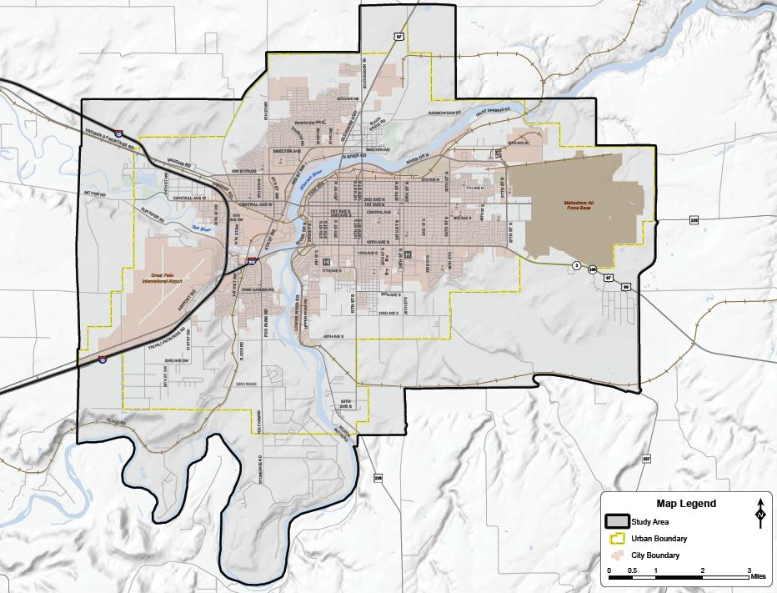
GREAT FALLS URBAN AREA BOUNDARY (IN YELLOW)

